EXPLORATORY DATA ANALYSIS FOR QUANTITATIVE DATA
- Installing required packages:
If you do not have R Markdown, you should also install it using this command:
install.packages(“rmarkdown”)
To publish your code nicely in a PDF file, you should install Tinytex using this command:
tinytex::install_tinytex()
To access data from the book, install the following package:
install.packages(“Sleuth2”)

- Using RStudio and R Notebook/R Markdown
Open RStudio. On the top left, choose to open a new R Notebook (look at figure below).
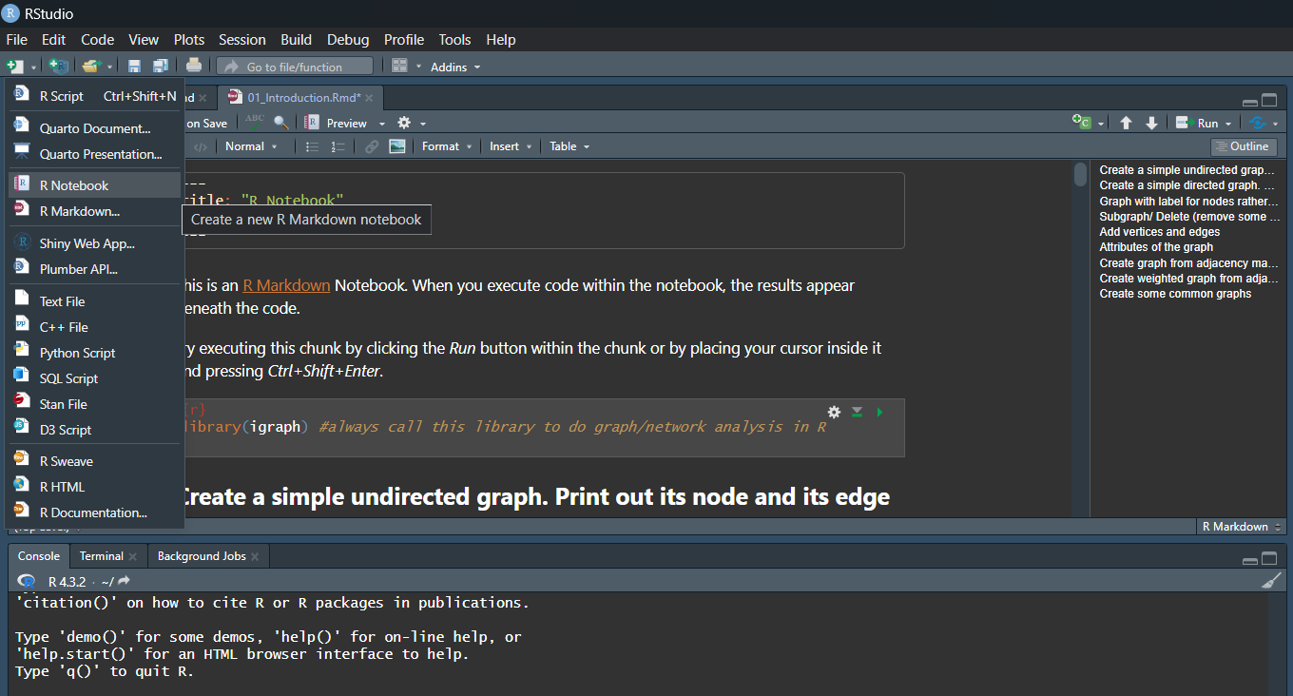
Figure 1: Open R Markdown Notebook
Now you can start entering your code in the code chunk. To go to a new chunk, use Ctrl+Alt+I. It is recommended that you break up your code into chunks so that it is easy to debug if needed to.

With R Notebook, you can create sections with titles within your code for organization purpose. To create section, simply go in between the code chunk and type the section name.

Finally, when you are done with coding, you can publish your code to HTML file, pdf file, and Word file. To do that, click on the Knit option and choose the file format you want (see below).
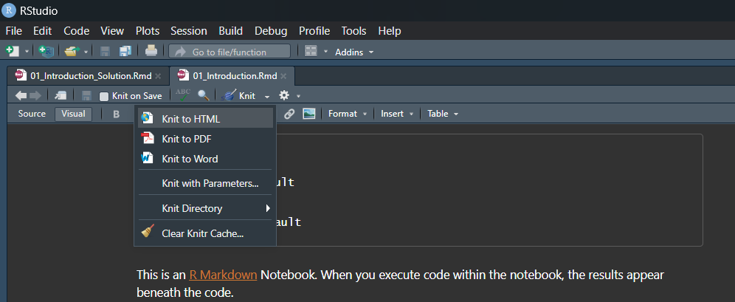
Figure 2: Knit options for your code.

- Change R directory:
It is really important that you know your R working directory and change the directory in R if you need to. To check the current R working directory, use:
getwd()
Here, R will give you the current directory of R. That means your data need to be loaded from this directory and your R files will be saved in this directory.

If this directory is not where you want to save your code, you will then need to change your working directory. For example, if you want to save and/or load files from “C:\Users\Desktop\RCodes”, use:
setwd(“C:/Users/Desktop/RCodes”)

- Import, view, and access csv data:
To import csv data, use the command:
data= read.csv(“name of the file.csv”).
Make sure to save the file in the same directory as your R workspace.

To view the first few rows of the data, use:
Head(data)

To view the last few rows of the data, use:
Tail(data)

To access a column of the data, use:
data$columnName
For example, if the data is named IQdata and it has two columns: id and IQ_score, type IQdata$IQ_score to access the IQ_score column.

- Stem plot:
The R command is stem(data, scale=whole number) with 1 as the default value for the scale parameter.
stem(data) gives default display. If the display appears bunched. We can double the stems using the scale argument
stem(data, scale=2)

Example 1: In the empty space right before the first code chunk (not in the code chunk), type “# Example 1”. This is to section out your code and make it look organized. Then, in the first code chunk, type the R command given in section 4 to import the data from “EDA_iq.csv”. Make sure to give it a name (a meaningful name such as “IQdata”, not just “a” or “data”) so that you can refer to it later. Use R commands to view the first few rows and the last few rows of the data.

Example 1 (Cont’d): Create a new code chunk using Ctrl+Alt+I and start typing your code in the new one. Draw a stem plot for this data. You can play around with the scale values (like 1 or 2) to see how the stem plots change.

- Histogram:
The R command is
hist(data, main="title", col="color name", prob=F)

prob=F uses the frequencies or counts-it is the default value whereas
prob=T uses the density (percentage) values

Other arguments include:
- breaks=c(…) specifies the sequence of endpoints. If this is not specified, R will automatically choose the bin size and bin numbers.
- xlab="name for the horizontal axis"
- ylab="name for the vertical axis"
- xlim= c(a,b) specifies the range of the horizontal axis
- ylim= c(a,b) specifies the range of the vertical axis

Example 2: In the empty space right after the previous code chunk you use for example 1, type “# Example 2”. Then, create a new chunk code to use for this example. Draw a histogram of the IQ score from the same data. Make sure to have a meaningful label for the x and the y axis.

- Box plot:
The R function to make a boxplot is
boxplot(data, main="title", col="color", ylab="variable name")
This yields a vertical boxplot by default.

Use the argument horizontal=T if you want a horizontal look.
boxplot(data, main="title", col="color", ylab="variable name", horizontal=T)

Example 3: In the empty space right after the previous code chunk you use for example 2, type “# Example 3”. Then, create a new chunk code to use for this example. Draw boxplot of the IQ score from the same data. Make sure to have a meaningful label for the x and the y axis.

- Numerical summaries of data:
The R function for 5-number summary is
quantile(data, c(0, 0.25, 0.5,0.75, 1))

The following command yields important summary of data:
summary(data)
mean(data)
sd(data)
var(data)
median(data)

Example 4: In the empty space right after the previous code chunk you use for example 4, type “# Example 4”. Then, create a new chunk code to use for this example. Compute the important statistics of the IQ score.

- Side-by-side plot:
This can be used when we need to compare data from different groups. For example, compare test score between students from calculus 1 section 1 and calculus 1 section 2.

To do side-by-side histogram, you need to
- unpack the data by group
- divide the plotting window into subplots by the command:
Par(mfrow=c(m,n))
Here, m is the number of rows and n is the number of columns.
- Do the histogram plot for each group.

To do side-by-side box plot, use the command:
boxplot(data$columnName ~ data$groupName, …)
You do not have to unstack the data with boxplot.

Example 5: In the empty space right after the previous code chunk you use for example 4, type “# Example 5”. Then, create a new chunk code to use for this example. Load the Bumpus data from the package Sleuth2. Then, draw a side-by-side box plot for the perished group and the survived group. To load this data, use (“case0201” is the name of this data in R):
library(Sleuth2)
Name of your data here=case0201

Example 5 (Cont’d): Draw a side-by-side histogram for the perished group and the survived group.

